Viewing Database and Table Structure
When working with a database, it is important to understand its structure: what tables exist, what columns they have, data types, and relationships between tables. In PostgreSQL, there are built-in tools in psql for this purpose, as well as external visualization tools such as ER diagrams.

\dt and \d commands
\dt - shows all tables in current DB:
Example:
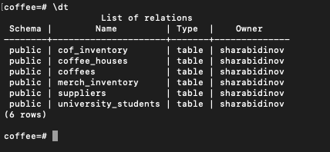

\d table_name - describe the exact table structure
Examples:
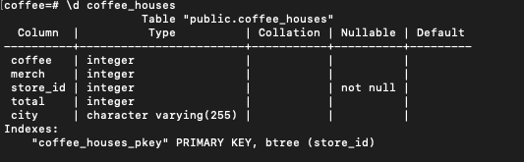

ER diagrams
ER diagrams are graphical representation of database structure
How to view ER Digram via pgAdmin?
DB section → Schemas → Tables → Right click → ERD for database

Example:
